1. https://www.atlantis-press.com/article/125983663.pdf

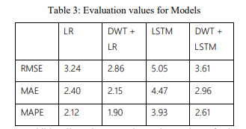

1. <https://ieeexplore.ieee.org/document/9290495>
   1. **Simple Regression models**

* 1. **Multiple Regression Model**

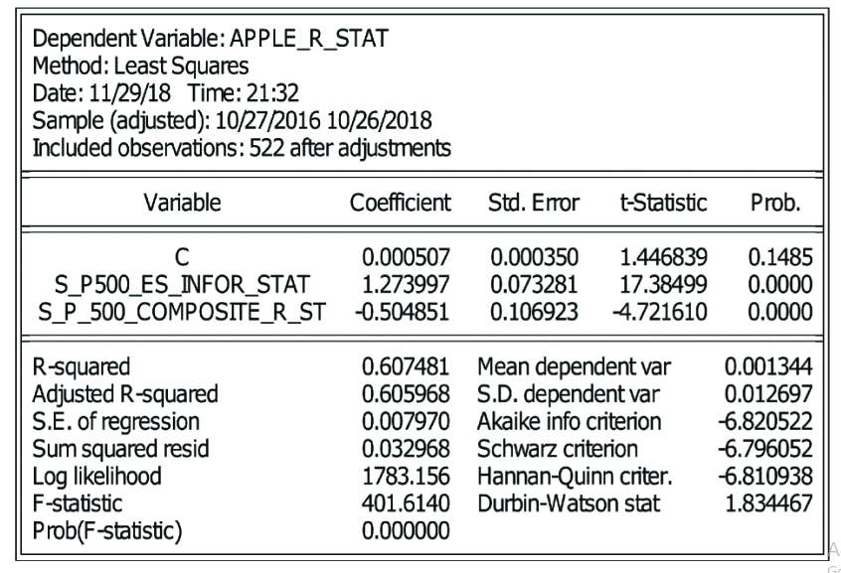

1. <https://escholarship.org/content/qt9zf2h3c1/qt9zf2h3c1.pdf?t=p7figq>

1. <https://arxiv.org/pdf/1909.12227.pdf>
   1. The results are normalized.

1. <https://www.sciencedirect.com/science/article/pii/S2405918818300060>
   1. For GOOGLE stocks.

